Read Me First - What I Found in Your Aspen Plus Work
Mahua flower to ethanol project | Prepared 21 August 2026
Hello my friend,
I sat down today with the three screenshots you sent me (the Kinetics page, the Species page, and the error messages page) and I went through everything as carefully as I could. I also spent time digging through published research papers so that whatever I tell you is backed by a proper reference, not just my opinion. I have written everything in three documents, and this one is the short summary. Please read this one first, then the other two when you have time.

The single most important thing I found
I have good news for you. Your numbers are not random or wrong guesses - almost all of them come from one real, published research paper. I found it:
Ccopa Rivera E., Costa A.C., Atala D.I.P., Maugeri F., Wolf Maciel M.R., Maciel Filho R. (2006). "Evaluation of optimization techniques for parameter estimation: Application to ethanol fermentation considering the effect of temperature." Process Biochemistry, volume 41, issue 7, pages 1682-1687. DOI: 10.1016/j.procbio.2006.02.009
Your values match the 34 degree Celsius column of Table 2 in that paper, almost digit for digit: the growth rate 0.373, the Ks of 4.1, the 76.9 (the paper says 76.866), the 107.7 (the paper says 107.685), the 9.041, and even your 19.78 is just 1 divided by the paper's 0.05055. So whoever gave you these values, or wherever you took them from, the original source is this paper. This is actually great, because now you can cite it properly in your report, and your examiner will see that your inputs have a real basis.
One honest caution though: that paper studied yeast growing on sugarcane molasses at 34 degrees Celsius, not on mahua flowers. Nobody has published Monod-type kinetic values for mahua flowers yet (I searched very hard, and I explain this in document 3). So using this paper's values is a reasonable and defendable choice, but you should say clearly in your report that the kinetics are borrowed from sugarcane fermentation, and you should run your reactor at 34 degrees Celsius so the numbers stay valid.

What is actually wrong (only three things)
- 1. Your reactor block. The red ERROR in your third screenshot says it plainly: the RBatch block does not accept Fermentation-type reactions. This is a rule of Aspen Plus itself, not your mistake in typing anything. AspenTech's own documents say fermentation reactions work in the BatchOp block (for batch) and the RCSTR block (for continuous). So block B4 must be replaced. Document 2 gives you the exact steps.
- 2. Yp:s = 0.5144 is physically impossible. This is the yield of ethanol from glucose. Chemistry itself puts a hard ceiling on it: from 180.16 g of glucose you can get at most 92.14 g of ethanol, which is 0.5114 g per g - never more. Your 0.5144 is above that ceiling, so no real fermentation can ever reach it (I suspect the 1 and the 4 simply got swapped while typing). I recommend you change it to 0.50, and I show why 0.50 is the best choice in document 2.
- 3. Ms = 0.0005 does not match the source paper. The paper this data comes from uses a maintenance value of 0.2, not 0.0005, and it handles maintenance in a different way than Aspen does. The clean fix, which makes your Aspen model match the paper almost exactly, is to set Ms = 0 and let the beta = 0.1 term do the maintenance work. The little bit of arithmetic behind this is in document 2, and it works out beautifully.

What is fine and should stay as it is
Everything else I checked is fine: the growth rate 0.373 per hour, Ks = 4.1 g/L, the logistic term values 76.9 and 107.7 with exponents 1 and 1.5, the yields 19.78 and 9.041, beta = 0.1, the zero activation and death rates, yeast as the biomass, NH3 as the nitrogen source, and glucose as the substrate. All of these are either directly from the Rivera paper or sit comfortably inside the ranges reported in other good papers. Document 3 goes value by value with references for each one.

About the yellow warnings
The three warnings about "gap species with negative coefficients" look scary but they are mostly informational. In simple words: Aspen balances the atoms (carbon, hydrogen, oxygen, nitrogen) behind the scenes using water, CO2 and hydrogen as filler species, and it warns you when it needs a small negative amount of one of them. Fixing Ms and Yp:s as above removes most of the problem, and the small warning that may remain does not damage your results. I explain each warning in plain words in document 2.

The three screenshots, for reference
So we are talking about the same things: screenshot 1 is the Kinetics page, screenshot 2 is the Species page, screenshot 3 is the error list.
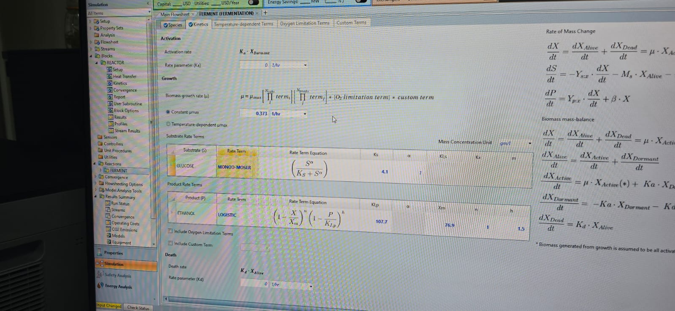
Screenshot 1 - Kinetics page (growth rate, Monod and logistic terms)
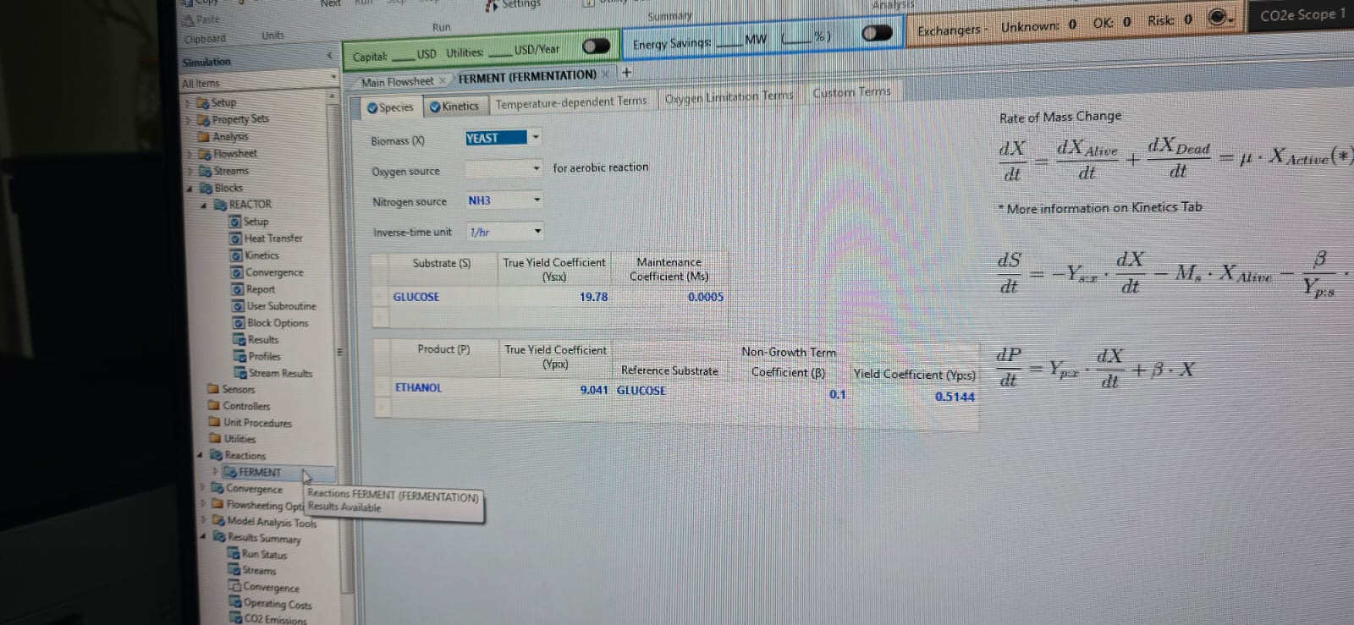
Screenshot 2 - Species page (yields, maintenance, beta)
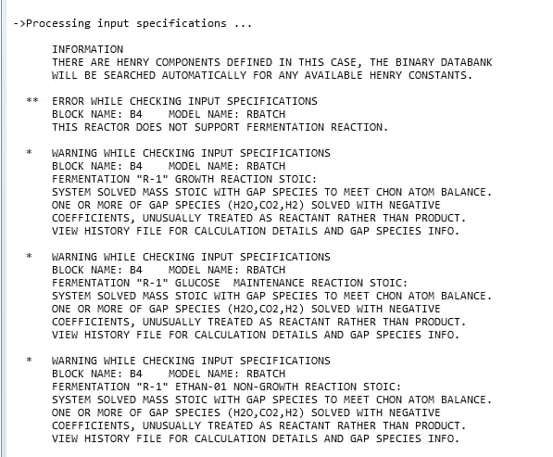
Screenshot 3 - the error and the three warnings

What to do now, in order
- Open document 2 and follow the steps to replace the RBatch block and change the two values (Ms and Yp:s).
- Re-run the simulation and check the red error is gone.
- Open document 3 when you write your report - it has every value checked against literature, plus the correct mahua flower numbers (sugar content, expected ethanol) with full references you can cite.

I did my best to verify everything against real papers, and where I could not fully verify something I have said so honestly in the documents. Still, please double-check the two or three key numbers yourself before your final submission - four eyes are better than two. If anything is unclear, call me.
Your friend,
Vishal

